Departmental Visit Report: Nursery Visit for Medicinal Plant Identification

Introduction:
As part of the academic curriculum and to enhance practical knowledge, the Department of Dravyaguna Vigyan, Shri Baba Mastnath Ayurvedic College organized an educational visit to a medicinal plant nursery. The primary objective of this visit was to familiarize students with various medicinal plants, their identification, cultivation practices, and therapeutic uses. Such experiential learning opportunities bridge the gap between theoretical knowledge and real-world application, enabling students to better understand the importance of plant-based medicine and biodiversity conservation.

The visit was conducted under the supervision of Dr. Manjula, Associate Professor, Department of Dravyaguna on 14-03-2026 (Saturday), who guided students throughout the session. The nursery served as a living laboratory, offering a wide variety of medicinal plant species in a well-maintained and organized environment. Students actively participated in the learning process by observing, questioning, and recording important details about each plant.

Objectives of the Visit
The departmental visit was planned with several key objectives in mind:

1. To help students identify different medicinal plants based on their morphological features.
2. To understand the medicinal properties and traditional uses of various plant species.
3. To gain knowledge about cultivation, propagation, and maintenance of medicinal plants.
4. To promote awareness about the importance of herbal medicine and sustainable practices.
5. To encourage interest in research and conservation of medicinal flora.

Overview of the Nursery
The nursery visited was well-structured and categorized into different sections based on plant types and uses. It included a diverse collection of herbs, shrubs, climbers, and trees known for their medicinal value. Each plant was properly labelled with its botanical name, common name, and uses, which made identification easier for students.
The nursery staff and experts provided valuable insights into plant care, soil requirements, irrigation methods, and seasonal variations affecting plant growth. The environment was clean, green, and conducive to learning, making it an ideal place for educational visits.

Learning Experience and Observations
During the visit, students were introduced to numerous medicinal plants such as Tulsi (Holy Basil), Ghritakumari (Aloe Vera), Neem, Ashwagandha, Brahmi, Pootiha, Ela, Tejapatra, Pashanabheda, Shatavari, Kadamba, Nirgundi, Karamarda and Lemongrass. The experts explained the identifying characteristics of each plant, including leaf shape, texture, aroma, stem structure, and growth pattern.

For instance, Tulsi was identified by its aromatic leaves and purple-green coloration, while Aloe Vera was recognized by its thick, fleshy leaves containing medicinal gel. Neem, known for its antibacterial properties, was discussed in detail, including its use in traditional medicine.

Students also learned about the active compounds present in these plants and their applications in treating various ailments. For example, Aloe Vera is used for skin care and wound healing, Ashwagandha for stress relief and immunity, and Brahmi for enhancing memory and cognitive functions.

The nursery experts emphasized the importance of organic farming practices and avoiding harmful chemicals to preserve the medicinal quality of plants. Composting, natural pest control, and proper irrigation techniques were demonstrated to the students.

Hands-On Activities
One of the most engaging aspects of the visit was the hands-on experience provided to students. They were given the opportunity to:

1. Observe and handle different plant specimens.
2. Learn propagation techniques such as stem cutting and seed sowing.
3. Participate in planting activities under supervision.
4. Learned how to record observations in field notebooks.

These activities helped students develop practical skills and a deeper appreciation for plant life. It also encouraged teamwork and active participation among students.

Importance of Medicinal Plants
The visit highlighted the significant role of medicinal plants in healthcare and traditional medicine systems. Students learned that a large portion of the global population still relies on herbal remedies for primary healthcare. Medicinal plants are not only cost-effective but also have fewer side effects compared to synthetic drugs when used appropriately.

Additionally, the importance of conserving medicinal plant species was stressed, as many of them are becoming endangered due to overexploitation and habitat loss. The nursery plays a crucial role in preserving these plants and promoting sustainable use.

Interaction with Experts
Students had an interactive session with nursery experts and horticulturists. They asked questions related to plant care, medicinal uses, commercial cultivation, and career opportunities in this field. The experts shared their experiences and encouraged students to explore research and entrepreneurship in medicinal plant cultivation.

This interaction enhanced students’ understanding and provided them with valuable guidance for future academic and professional pursuits.

Conclusion
The departmental visit to the medicinal plant nursery was an enriching and informative experience for all participants. It provided students with practical exposure to the identification and uses of medicinal plants, reinforcing their classroom learning. The visit successfully achieved its objectives by enhancing students’ knowledge, skills, and awareness regarding plant-based medicine.

Such educational visits are essential in developing a holistic understanding of subjects and fostering a sense of responsibility towards nature and sustainable practices. The experience will undoubtedly benefit students in their academic journey and inspire them to contribute to the field of medicinal plant research and conservation.

Acknowledgement
We express our sincere gratitude to the nursery management and staff for their cooperation and for sharing their valuable knowledge with us. We also thank our faculty members for organizing this visit and guiding us throughout the learning experience.

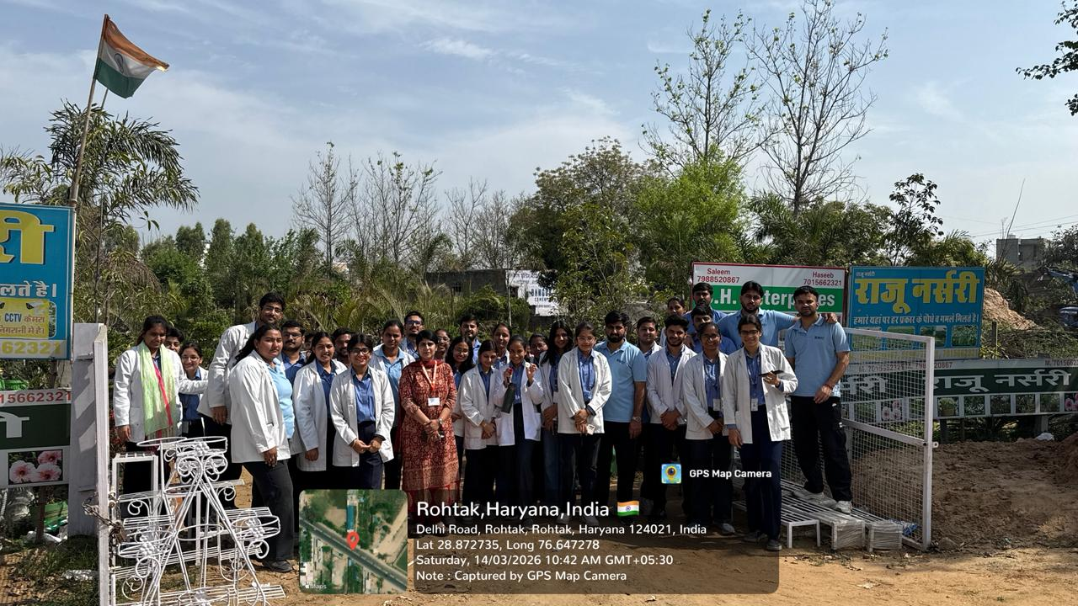

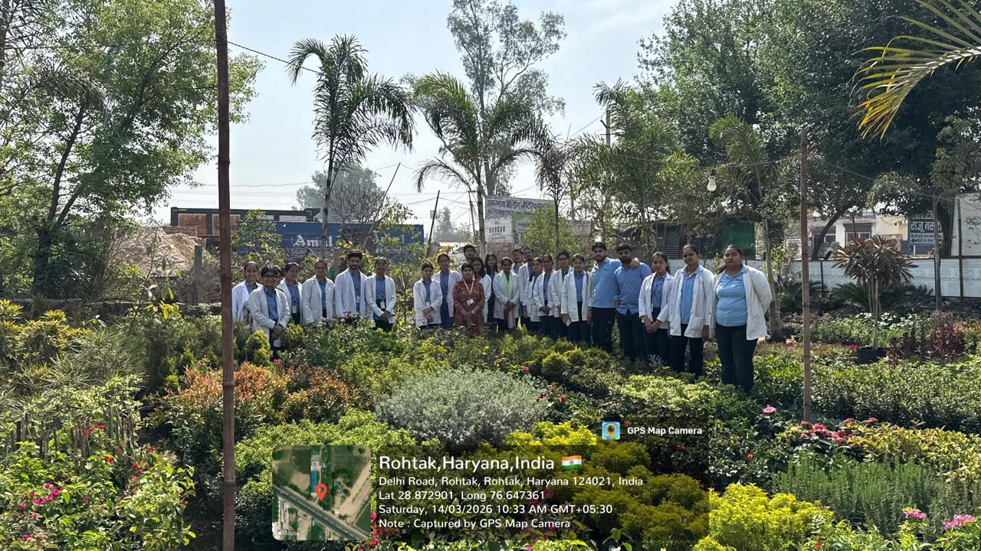
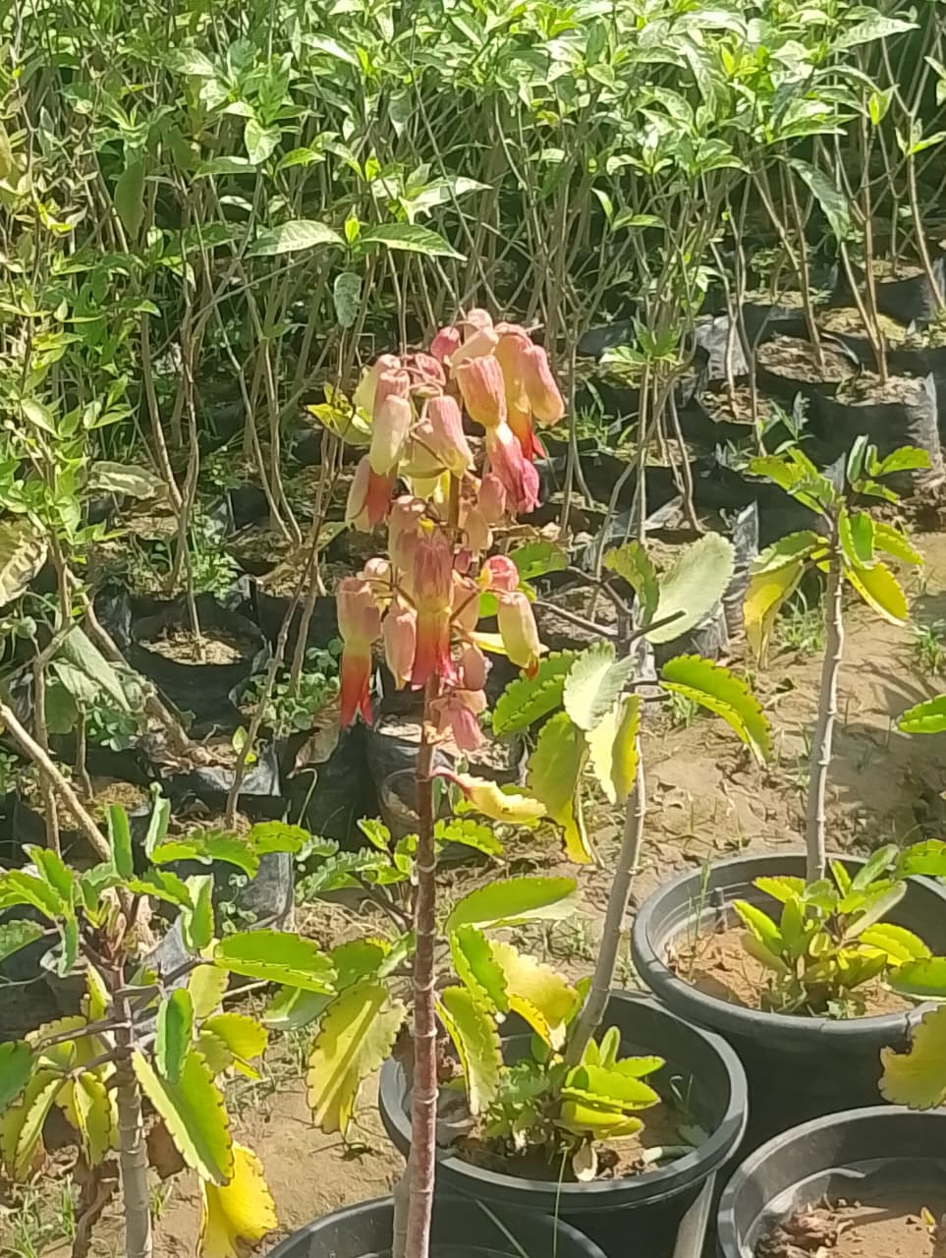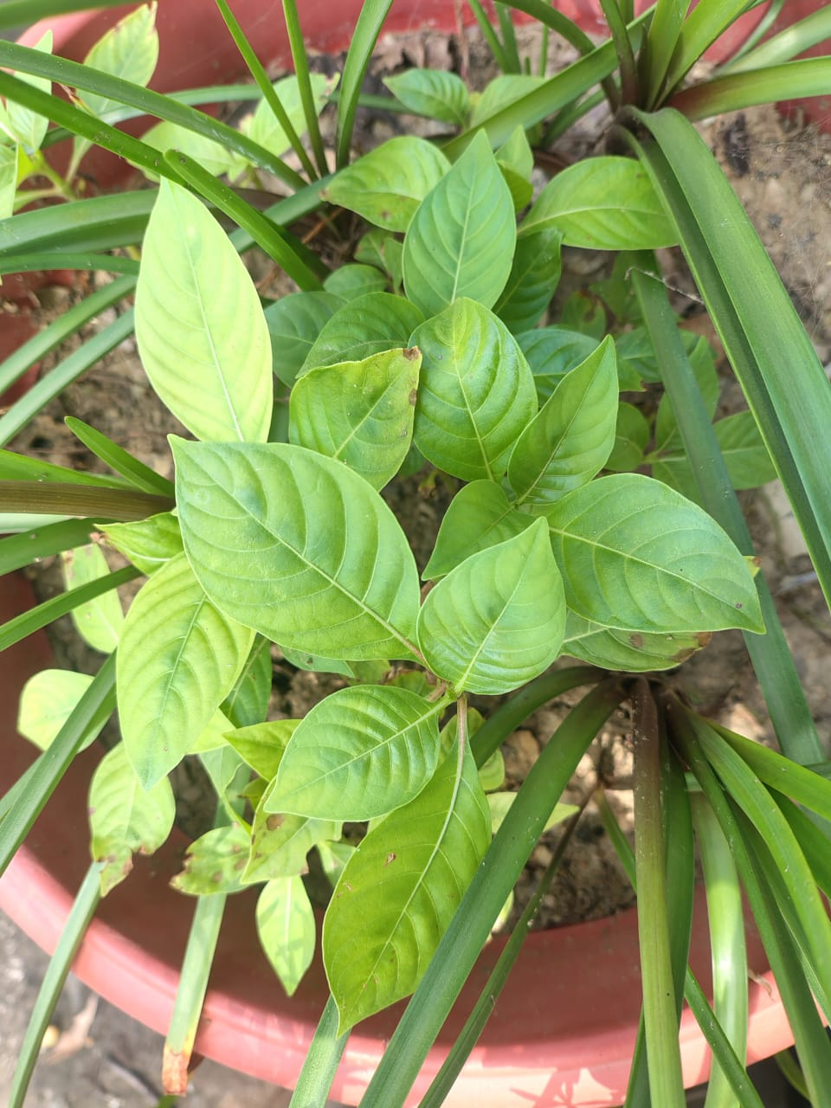
Pashanabheda Flowering Kadamba

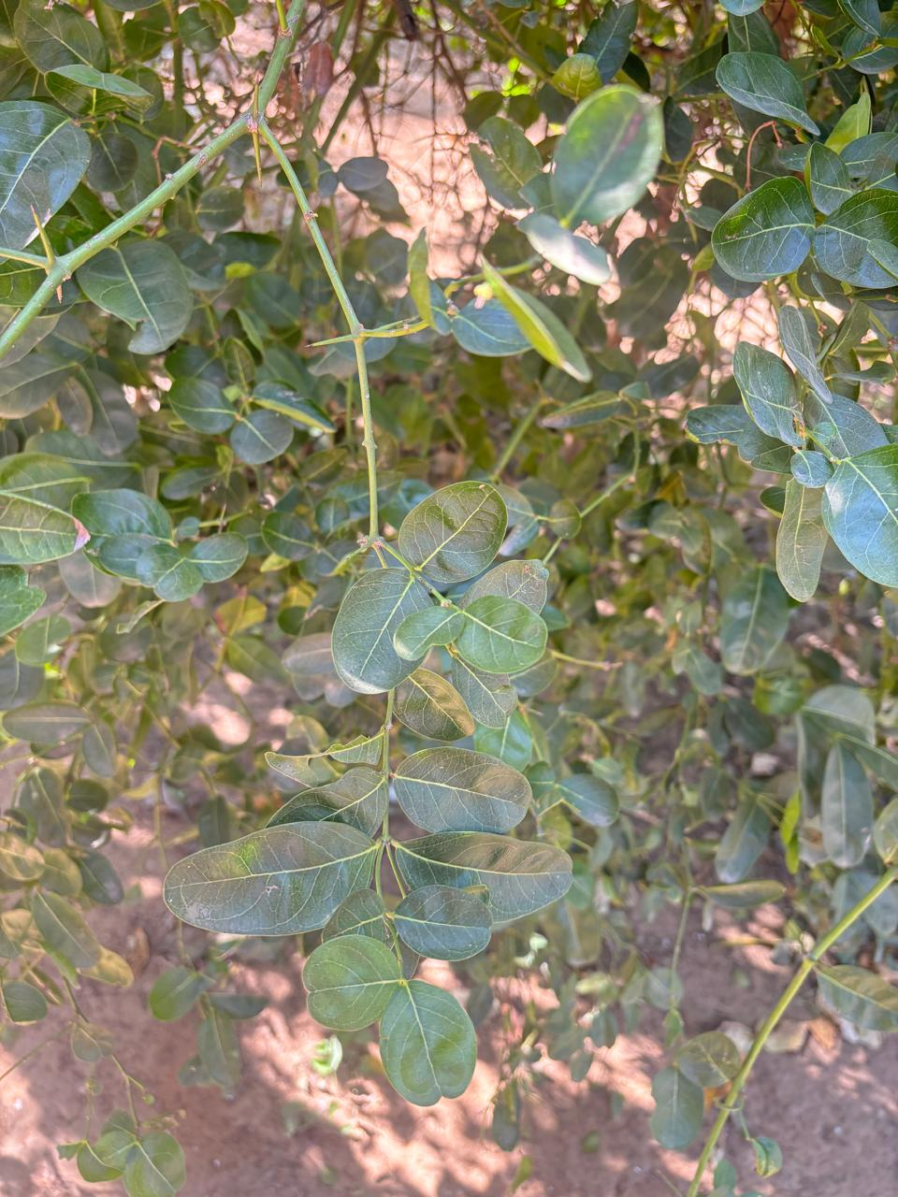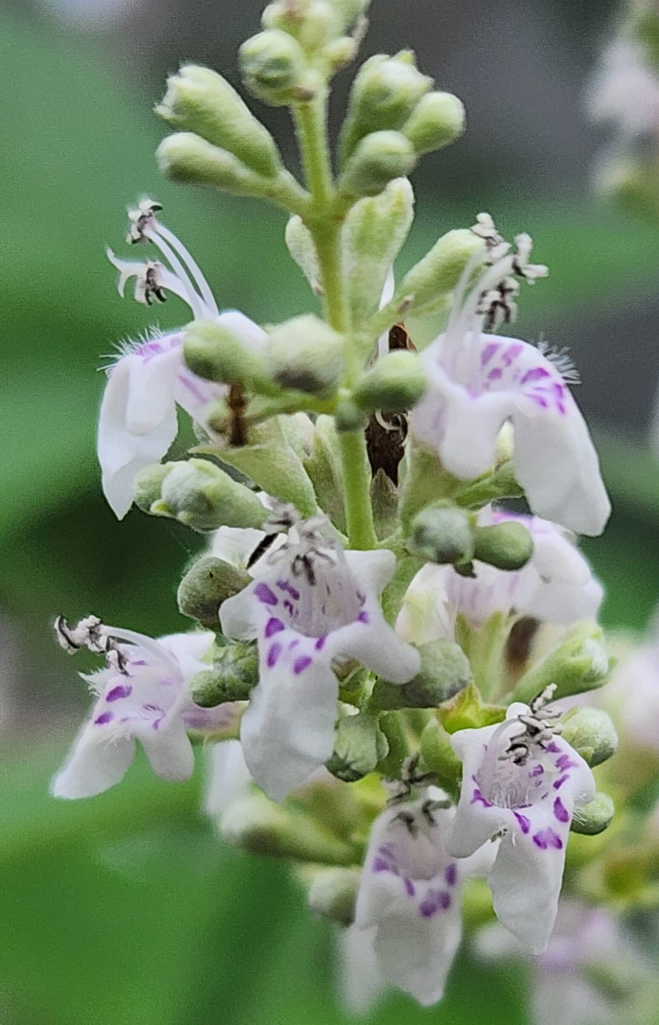
Karamarda Nirgundi Flowering

